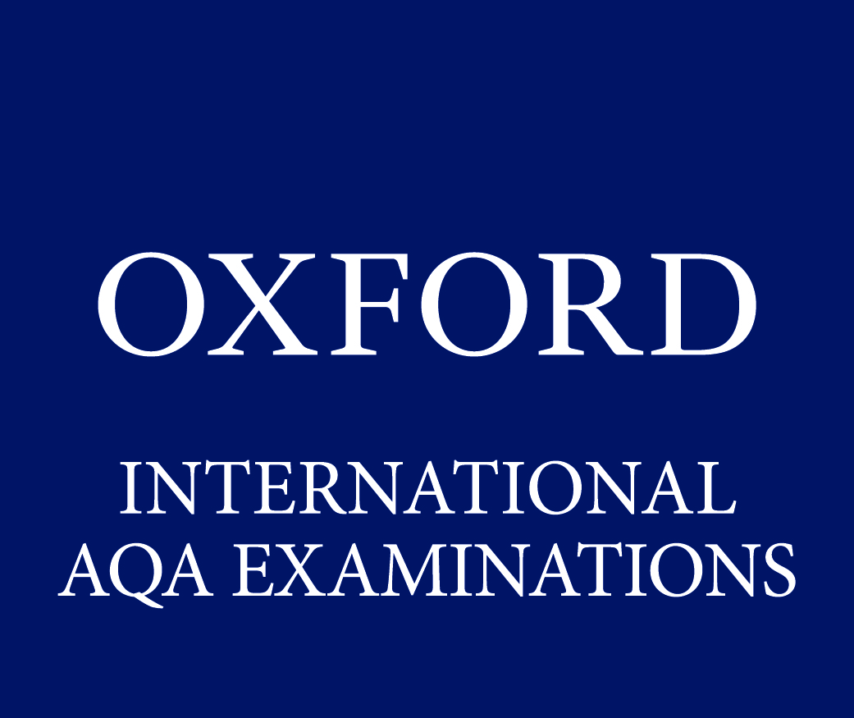

INTERNATIONAL
GCSE
Combined science chemistry
(9204)

Outline schemes of work – review version
For teaching from September 2016 onwards
For International GCSE exams in June 2018 onwards

This scheme of work suggests possible teaching and learning activities for each section of the specification. There are far more activities suggested than it would be possible to teach. It is intended that teachers should select activities appropriate to their students and the curriculum time available. The first two columns summarise the specification references, whilst the learning outcomes indicate what most students should be able to achieve after the work is completed. The Resources column indicates resources commonly available to schools, and other references that may be helpful. The timings are only suggested, as are the possible teaching and learning activities, which include references to experimental work. Resources are only given in brief and risk assessments should be carried out. It should be noted that some uniform resource locators (URLs) may not be accessible from all regions.

Many centres will have access to a virtual learning environment (VLE), and Key Stage 4 related science materials. In the resources, reference is made to VLE and interactive software. Most VLE software providers have similar presentations on the topics. Before using any presentation, teachers are reminded that they should decide in advance which slides are most suitable to achieve the learning objectives and edit the presentation accordingly before the lesson.

Throughout this specification students will be expected to write word equations and write and balance symbol equations for reactions specified.

Spec ref. | Summary of the specification content | Learning outcomes  What most students should be able to do | Suggested timing (lessons) | Possible teaching and learning activities  Homework | Resource | Examination ‘hints and tips’  Students should:
3.7 Atomic structure and the Periodic Table
3.7.1 Solids, liquids and gases
3.7.1a | Matter can be classified in terms of the three states of matter. | Students should be familiar with the states of matter and be able to name each inter-conversion process.  They should be able to describe and explain their  inter-conversion in terms of how the particles are arranged and their movement.  They should understand the energy changes that accompany changes of state. | 1 | Discuss: Revise states of matter.  Activity: Students make chart to show differences in properties and structure of solids, liquids and gases.  Activity: Melt ice to water, or cool molten stearic acid back to a solid. Plot a graph of temperature against time.  Discuss: The plateau of the graph in terms of energy being absorbed and used to break bonds, or energy being given out by bonds forming. | Ice, beakers, thermometers, stop watches, stearic acid in boiling tube, heating equipment, graph paper.
3.7.1b | Evidence for the existence of particles can be obtained from simple experiments. | Students should be familiar with simple diffusion experiments such as  Br2/air, NH3/HCl, KMnO4/ water. | 1 | Demo; Show suitable examples of diffusion experiments or other experiments to show that matter is made from particles.
3.7.2 A simple model of the atom
3.7.2a | All substances are made of atoms. A substance that is made of only one sort of atom is called an element. There are about 100 different elements. Elements are shown in the Periodic Table. | Know that substances are made of atoms. State that substances made of only one sort of atom are called elements.  Know that elements are found in the Periodic Table. State where metals and non-metals appear in the Periodic Table. | 2 | Activity: Use the Periodic Table to elicit answers about:  - list of known elements (about 100)  - location of non-metals and metals  - groups and periods  - idea of atoms.  - use of symbols and rules for their use  - proton number, mass number.  Task: Students make notes on their Periodic Table, and in books. | Periodic Table for chemistry.  Information about the Periodic Table can be found on the BBC website at bbc.co.uk/education by searching for ‘Periodic Table’.  VLE/interactive software eg Periodic Table slides.
3.7.2b | Atoms of each element are represented by a chemical symbol, eg O represents an atom of oxygen. | Know that symbols represent atoms of different elements.  Knowledge of the chemical symbols for elements other than those named in the specification is not required. |  |  |  | Be able to use symbols confidently.
3.7.2c | Atoms have a small central nucleus, which is made up of protons and neutrons, and around which there are electrons. | Know the structure of an atom. |  | Task: Students view/draw diagrams of basic atomic structure naming sub-atomic particles. | VLE/interactive software, eg The Atom.
3.7.2d | The relative electrical charges are as shown:  Proton – charge of +1  Neutron – no charge  Electron – charge of -1 | Know the charges on sub-atomic particles. |  | Discuss: charges on sub-atomic particles, and produce chart in books. | View the atomic structure PowerPoint presentation at iteachbio.com/Chemistry/Chemistry/Atomic%20Structure.ppt | .
3.7.2e | In an atom, the number of electrons is equal to the number of protons in the nucleus. Atoms have no overall electrical charge. |  |  | Task: Work out number of electrons, protons and neutrons in first ten elements of Periodic Table. Results as diagrams or chart in books.
3.7.2j | The relative masses of protons, neutrons and electrons are:  Name of particle mass  Proton 1  Neutron 1  Electron Very small |  |  | Discuss: Give the students the mass numbers for elements numbers 1-10. Ask them to find the pattern between the mass numbers and sub-atomic particles. |  | Know the difference between atomic number and mass number.
3.7.2f | The number of protons in an atom of an element is its atomic number. The sum of the protons and neutrons in an atom is its mass number. | Students will be expected to calculate the numbers of each sub-atomic particle in an atom from its atomic number and mass number. |  |  |  | Be able to calculate numbers of protons, neutrons, and electrons in an atom, using the Periodic Table.
3.7.2g | Atoms of the same element can have different numbers of neutrons; these atoms are called isotopes of that element. |  |  | Task: Students to complete a chart showing atoms of same element having different numbers of neutrons, to develop idea of isotopes.
3.7.2h | Atoms can be represented as shown in this example:  (Mass number) 23  Na  (Atomic number) 11 |  |  | Introduce representation of different atoms as:  40  K  19  Homework: Students draw structures of several named atoms using the Periodic Table.
3.7.2l | The relative atomic mass of an element (Ar) compares the mass of atoms of the element with the ¹²C isotope. It is an average value for the isotopes of the element. | Students will not be expected to calculate relative atomic masses from isotopic abundances. |  | Discuss: Why does chlorine have an A_{r} of 35.5? Introduce idea of average value for mass number, and relate to ¹²C isotope.

