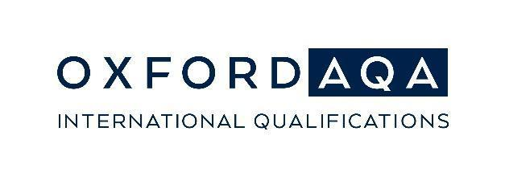

Go Further Awards 2023

Social media toolkit for schools

This social media toolkit contains post templates and visuals that OxfordAQA schools can adapt to your social media platforms to promote your 2023 Go Further Awards winners.

Please make sure that appropriate privacy consent has been received prior to publication. Neither OxfordAQA nor Oxford University Press can be held responsible for the content published on your school’s social media.

How to interact with us on social media

Tag us in your posts and we will be able to react and celebrate your Go Further Award winners with you!

- Tag us on Facebook using @OxfordAQA
- Tag us on LinkedIn using @OxfordAQA
- Use the hashtags #GoFurtherAwards, #OxfordAQA to join the conversation

Suggested posts

Join us in celebrating the winners of this year’s Go Further Awards, awarded by @OxfordAQA. [Your school name] is proud of the achievements of all our students who have achieved excellence in their exam results in 2023!
#GoFurtherAwards #OxfordAQA #InternationalEducation

The Go Further Awards 2023 have been awarded to [Number] of our @OxfordAQA students who have achieved outstanding exam results in the May/June exam series.Congratulations to all!
http://ow.ly/jstf50KVAbv
#GoFurtherAwards #OxfordAQA #InternationalEducation

We are proud to announce that the international exam board @OxfordAQA has awarded [name of student] with the prestigious Student Achievement Award for 2023. [name of student] has achieved the best exam result in [specify country or region] for the OxfordAQA International [GCSE/AS level/A-level] [specify subject] exam. [Your school name] are proud of [name of student]’s truly outstanding achievement!

#GoFurtherAwards #OxfordAQA #InternationalEducation

Visuals and photo frames for social media

Feel free to use the assets and photo frame provided here to celebrate your Go Further Awards winners. The photo frame has a transparent background and can be added to any photos of your winners you would like to share on social media.

Please note: By using the assets and photo frame you will consent to not use images provided in a way that may be perceived as representing that your school and OxfordAQA are the same entities, affiliated in some way, or engaged in any other business partnership than that of the center teaching OxfordAQA qualifications or the Oxford International Curriculum and entering students for OxfordAQA exams. Please do not alter the assets/ photo frame in any way.

Celebrate with our Facebook filter

You are warmly invited to share the link for the Go Further Awards Facebook Filter with your award winners.

Access the filter here: https://www.facebook.com/fbcameraeffects/tryit/750402859406371/

By opening the link on a mobile device, Go Further Awards winners can use the filter and share their success with their friends and network.

We are looking forward to seeing your Go Further Awards 2023 winners on social media,

With best wishes,
The OxfordAQA team

OxfordAQA (Oxford International AQA Examinations) is a partnership between AQA, the UK’s largest awarding body, and Oxford University Press, a department of the University of Oxford. We offer globally relevant international GCSEs, AS and A-levels around the world

