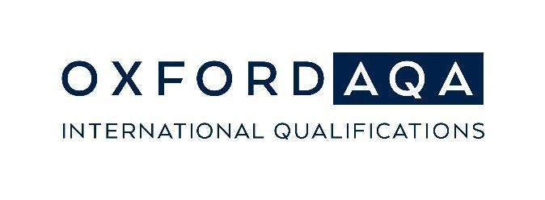
Go Further Awards 2023: Student Achievement Award
Dear <parent/guardian name>
We are delighted to let you know that your <son/daughter/student name> has been awarded a Go Further Student Achievement Award. This exciting award is brought to us by the team at OxfordAQA and is in recognition of outstanding exam performance <in International GCSE/AS/A-level - subject title>.
The Go Further Awards play an important part in recognising learner achievements in our school and demonstrate our commitment to outstanding teaching and learning.
The awards are available in the following categories:
- OxfordAQA Top in Country
- OxfordAQA Top in Region
- OxfordAQA Top in World
We will receive an awards certificate for your son/daughter from OxfordAQA in November.
In the meantime, please do not hesitate to get in touch if you have any questions or concerns.
Best wishes
<School signature and contact details>
For more information about the Go Further Awards: oxfordaqa.com/why-us/go-further-awards/
For more information about OxfordAQA: oxfordaqa.com

