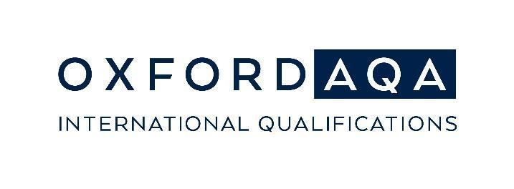

Optional Resource
Use the hashtags #GoFurtherAwards, #OxfordAQA to join the conversation.
You can use the below template press release to share your school’s success online and in print. Complete the highlighted sections with your information and then share with local newspapers, or even put it on your school blog!
Go Further Awards 2023 press release template for schools
[Your school name] celebrates award winners in the Go Further Awards 2023
[Number] students from [Your school name] have been confirmed as award winners in the 2023 Go Further Student Achievement Awards.
These awards recognise learners that have achieved excellence and our students have once again surpassed expectations by demonstrating a consistent commitment to learning!
OxfordAQA Student Achievement Award winners
These prestigious awards are granted to the OxfordAQA learner who gained the highest exam marks in their country or region for a single subject at International GCSE or AS/A-level. We are extremely proud to announce that the following learners have gained this award.
[Introduce award winners, eg:] The award winning students from [Your School name] were [student name(s)], who received the [OxfordAQA International GCSE [subject] [Top in region/ Top in country] award, [student name(s)] who received the [OxfordAQA International AS level) [subject] [Top in region/ Top in country] award, [student name(s)] who received the [OxfordAQA International A-level [subject] [Top in region/ Top in country] award [provide further explanation for each of the students if desired].
[Name], the [principal] of [your school name], said:
[“your quote here”]
The Go Further Awards were presented to students by [name] in a ceremony at [include details of event.]
[Name], one of the award-winning students, said:
[“student’s quote here”]
[Your school name] has been teaching OxfordAQA qualifications since [year]. [Your school name] has been following the Oxford International Curriculum since [year].
OxfordAQA – the abbreviated name for OxfordAQA International Qualifications – is a partnership between Oxford University Press, a department of the University of Oxford, and AQA, the UK’s largest provider of GCSEs and A-levels. The qualifications are specially designed to suit the needs of students studying in international schools, whilst being aligned to the standard of the GCSEs and A-levels that students take in England.
For more information about the Go Further Awards: oxfordaqa.com/support/go-further-awards/
For more information about OxfordAQA: oxfordaqa.com

