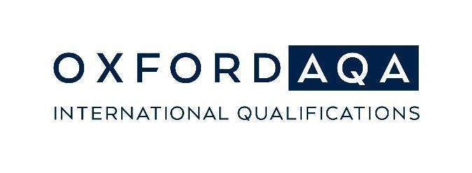
OxfordAQA Go Further Awards 2024:
Student award winners

Dear <parent/guardian name>,

We are delighted to let you know that your <son/daughter> <student name> has been awarded an OxfordAQA Go Further Award. This exciting award is brought to us by the team at OxfordAQA and is in recognition of outstanding exam performance in <International GCSE/AS/A-level - subject title>.

The OxfordAQA Go Further Awards play an important part in recognising learner achievements in our school and demonstrate our commitment to outstanding teaching and learning. The awards are available in the following categories:
- OxfordAQA Top in Country
- OxfordAQA Top in Region
- OxfordAQA Top in World

We will receive an awards certificate for your <son/daughter> from OxfordAQA in November.
In the meantime, please do not hesitate to get in touch if you have any questions or concerns.

Best wishes
<School signature and contact details>

For more information about the Go Further Awards: oxfordaqa.com/why-us/go-further-awards

For more information about OxfordAQA: oxfordaqa.com

- - - - - - - - - END - - - - - - - - -

