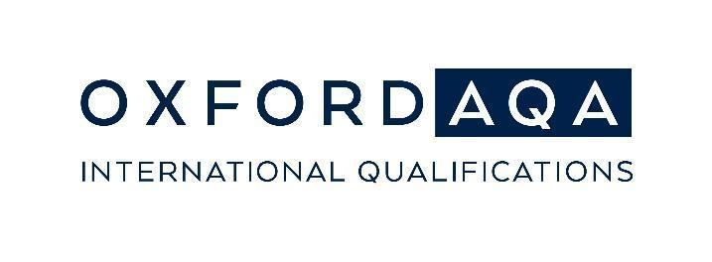
OxfordAQA Go Further Awards 2024
Social media toolkit for schools

This social media toolkit contains post templates and visuals that OxfordAQA schools can adapt to your social media platforms to promote your 2024 OxfordAQA Go Further Awards winners.

Please make sure that appropriate privacy consent has been received prior to publication. Neither OxfordAQA nor Oxford University Press can be held responsible for the content published on your school’s social media.

How to interact with us on social media
Tag us in your posts and we will be able to react and celebrate your OxfordAQA Go Further Award winners with you!
- Tag us on Facebook using @OxfordAQA
- Tag us on LinkedIn using @OxfordAQA
- Use the hashtags #GoFurtherAwards, #OxfordAQA to join the conversation

Suggested posts (3 options):
1 | Join us in celebrating the winners of this year’s Go Further Awards, awarded by @OxfordAQA. [Your school name] is proud of the achievements of all our students who have achieved excellence in their exam results in 2024!  #GoFurtherAwards #OxfordAQA #InternationalEducation
2 | The Go Further Awards 2024 have been awarded to [Number] of our @OxfordAQA students who have achieved outstanding exam results in the May/June exam series. Congratulations to all!  https://www.oxfordaqa.com/why-us/go-further-awards  #GoFurtherAwards #OxfordAQA #InternationalEducation
3 | We are proud to announce that the international exam board @OxfordAQA has awarded [name of student] with the prestigious Go Further Award 2024. [name of student] has achieved the best exam result in [specify country or region] for the OxfordAQA International [GCSE/AS level/A-level] [specify subject] exam. [Your school name] are proud of [name of student]’s truly outstanding achievement!  #GoFurtherAwards #OxfordAQA #InternationalEducation

Social media images
Feel free to use the assets provided by us to celebrate your Go Further Awards winners.

Please note: By using the assets you will consent to not use images provided in a way that may be perceived as representing that your school and OxfordAQA are the same entities, affiliated in some way, or engaged in any other business partnership than that of the center teaching OxfordAQA qualifications or the Oxford International Curriculum and entering students for OxfordAQA exams. Please do not alter the assets in any way.

We are looking forward to seeing your Go Further Awards 2024 winners on social media.

With best wishes,
The OxfordAQA team

